Wise Words: Eye of the Tiger
Gary Wise
Thursday, January 10, 2002
I used to be a tournament player.
A long time ago, I learned how to play Magic from an old friend named Shawn Altbaum. Shawn and I congregated more nights than not at a coffee house/restaurant called Toby's Good Eats for almost seven years. The food was mediocre, and coffee pretty bad, but they knew us there and we were allowed to buy a five hour coffee and play games. We went through Hearts and Poker, Dungeons and Dragons, Euchre and an old Yiddish game called Clubbiesh, and one by one we'd get to the point where the friends who joined us would play for third place. We were obsessed with getting better, and while I would often pass Shawn by a little in the games we'd play, it would never be by enough that it wasn't competitive. I loved our games.

I needed to win. It was the only thing I cared about.
I left Toronto when I was twenty-one to pursue a film degree at the University of Windsor, and for almost half a year, my life was without games. This was an entirely new concept for me, as I came from a family for who games were a way of life. My father had played games constantly from when he was a young child and, possessed of the same competitive streak I am, became Canada's best Scrabble player. When others started taking Scrabble more seriously, my father became the game's top tournament director. Games had always been integral, so those six months left me frothing at the mouth. I came home for March break needing a fix.
Shawn introduced me to what he called 'D&D without the role playing' one night at Toby's, and I hated it immediately. He hadn't fully explained the rules and was more concerned with trying out his latest deck, a Serra Angel, Sengir Vampire, Winter Orb monstrosity, and after taking my thrashings, I was sure I'd never want to play again. The next night though, Shawn explained the rules a little more clearly, and by the end of the week I'd bought my first cards. That night, I went to the Gas Works in Toronto (You may have seen it in Wayne's World). The cards were stolen from my coat. I still long for that Shivan.
Taking the theft as an omen, I knew Magic was a bad idea, and gave it up when I went back to school, but WotC was on the case. There, I saw a guy named Mark Brombacher playing with a visiting friend (I think his name was Chris LeSavage) playing the game, and I approached them in the hopes they would reintroduce me to the game.
I immediately went about getting my hands on as many cards as I could, gutting people in trades, playing for ante and what have you, and three months later, with my brand new Chaos Orb in tow, I headed back to Toronto to duel with Shawn. I dropped the Orb destroying the eighteen lands he had sitting in a pile. Three months later, Shawn quit playing Magic. In the year and a half before I left Toronto, I think I got together with him once. I wish I had let him win a few more games, but the competitive fire was burning. That's my biggest regret from my time in this game.
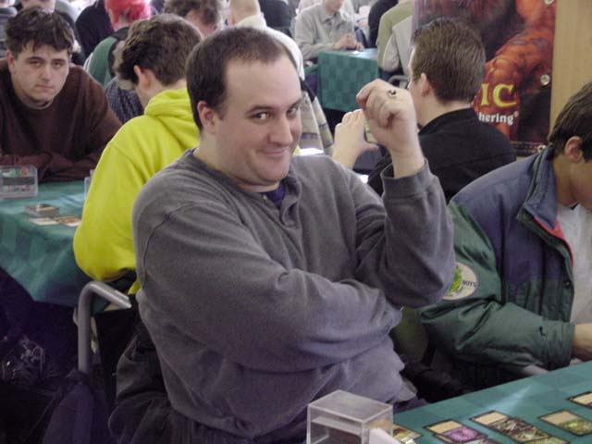
Pretty soon, I was going to Magic tournaments, and when I did, I took them pretty seriously. Everything I did was tactical, from conversing about deck preferences to dancing on tables, in my mind, there was a reason for doing so that might draw me one insignificant step closer to victory.
I needed to win. It was the only thing I cared about. Morality went out the window when it was the difference between victory and defeat. I even went so far as to cheat (a habit I'd kicked before my first Pro Tour) when I felt I needed to, because winning was a drug. It wasn't about the Mox I would get for winning the tournament, it was about the recognition that comes with being the best at what it is that so many people are choosing to do with their time. When everyone wants to be as good as you are, begrudgingly or not, you get respect for having achieved that plateau. That's all that went through my mind. I eventually stopped cheating thanks to the dual realization that I was wronging my peers and the respect was artificial, thanks to the means by which I was achieving it, instead rules lawyering and learning to play the game better. I was never the best player in Toronto, but I became good enough that despite having alienated a lot of people with my attitude, they knew that playing against me in a tournament wasn't something they really wanted to do. But it still wasn't enough.
Once I started becoming competitive on the PTQ circuit, I was introduced to the Magic Dojo. The Dojo provided me with everything I needed: information on how to get better, and a forum through which I could establish myself as a presence in the community. I didn't think of my writing tournament reports in that way, but as I look back now, I realize I really just wanted to be known, and known for being good.
I wrote my first tournament report after winning a Mirage-block qualifier, and two weeks later, I got an email from Alex Blumke thanking me for helping him qualify. For those of you who don't know, Alex isn't just an internet writer who blows the lid off of cheating scandals: he's a former World Champion. Before there was a Pro Tour, there were two World Championships held, and Alex won the second. His email honored me as much as any I've ever received (though some have come close), because, as I understand it now, it meant that I was achieving my goals: I had succeeded in changing the course of events a continent away for a player who'd already achieved the foothold I was trying to find.
My first Pro Tour was Dallas, and it was memorable. I trash-talked Hammer, something that just wasn't done. I played U.S. Champion Dennis Bentley and PT champ Mike Loconto. I money split with Terry Borer, played eventual winner Paul McCabe's deck and finished 5-4. Back then, when I went to a tournament, I would do whatever I had to in order to be my tournament best: shave daily so as to have a positive self image, eat very little, as food will sate the senses, ask for personal information from each of my opponents so I could use it when deciding if I should try for a bluff of some sort. I was loud, obnoxious, and admittedly dumb at times, but I knew that when it came to focus, I was ready. Between rounds, I would go to the bathroom, stare myself down and convince myself I was indestructible… the intellectual equivalent of football players butting heads I guess. I was intense if nothing else, and I knew that intensity would give me an edge in a game that everyone credits for being intellectual, but relatively few understand is equally psychological.

I knew that intensity would give me an edge in a game that everyone credits for being intellectual, but relatively few understand is equally psychological.
Now, that edge seems to be gone.
I'm not entirely sure why, but around two years ago, my edge started to slip. Maybe it was because I finally made my first Top 8, but while I still looked forward to playing with enthusiasm but I didn't seem to be doing it with intensity. At Pro Tour-New York 2000, I went to Skaff Elias and told him it was time for me to become a writer who plays instead of a player who writes, but with Potato Nation's win, I was on the Masters for the next year and that idea was shelved. I still didn't have that same intensity though.
Early in 2001, I was in a match where my opponent lied to a judge, costing me the match and knocking me out of contention for Top 8 in the tournament in question, and I was devastated. I proceeded to throw away my next match on a play a seven year old child wouldn't have made, because of how angry I was at the events that had transpired, and since then, my intensity has completely drained from my person when engaged in tournament situations.
I was interviewed by a number of television reporters at Worlds 2001, being the local pro, and when I watched the video late that night, I noticed that for the first time in as long as I could remember, I was playing in a Pro Tour without having shaved the night before. In the past, I would never have let the little things like that slip. I've always been a firm believer in maintaining a positive self image going into tournaments and doing all the little things you have to do to make that possible, and there I was, half a week's growth, playing the first day of World Championships. I hardly recognized myself.
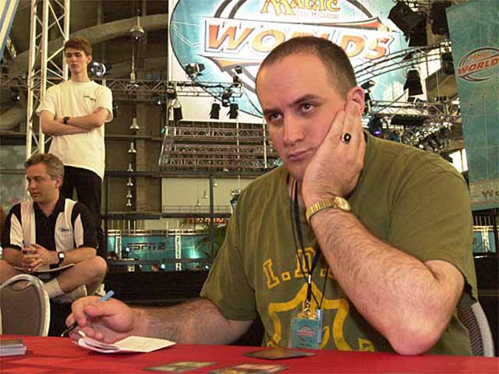
For the past few Pro Tours, I've found myself sitting at the table playing my games, but my focus has been left wanting. It seems that the politics of the game have become paramount and the game itself secondary, and I know that isn't the way it should be. For any player worth a lick, regardless of their skill level, Magic should be more than a game: it should be a passion. I think it's time for me to try and rekindle that passion.
In San Diego, I need to finish in the Top 48 or fall off the gravy train, and while I'm qualified for Osaka by virtue of a qualifier victory, falling below threshold would be a personal low for me. I've been one of the 50-100 players who has qualified for Pro Tours via PT points for each Pro Tour since PT-NY 3. To show you how long ago that was, it was Jon Finkel's fist PT win, Mark Justice was in Top 8, and Kai Budde had never played in a Pro Tour, so maintaining that distinction is pretty important to me. Regardless of what everyone else thinks, I'm feeling a fair amount of pressure to perform, and its all coming from myself.
Here's my plan for San Diego: I'm going to play Alex Anderson's Upheaval deck in the Gateway because it suits my style and I love the card. I'm going to do all the little things I used to do that got me through the qualifiers of old and got me onto the gravy train. I'm going to ignore those people who would want me to give them negative attention and I'm going to go to the washroom before every match and slap myself silly until I'm ready to play Magic, and play Magic right.
I think I'm pretty much ready with regards to the format. I know the cards, have drafted live weekly and drafted three or four times a day for the last six weeks on Magic Online. I'm enthused about Odyssey Limited in that it is probably the most skill-intensive Limited format ever created (I can't wait for Torment) and feel like this is a tournament I'm capable of doing well in. Make that I'm sure I should do well in.
I think I'm a pretty good Magic player when I can cut through the crap, and while I haven't done a good job of that lately, I'm focused on doing so this time. If I don't make Top 48, I'll just redouble my efforts and keep fighting my way back, but if all goes according to plan, none of that will be necessary. I have a good team and good friends around me, and they make weakness an impossibility: As long as my head is in the game, I'll survive and I'll thrive.
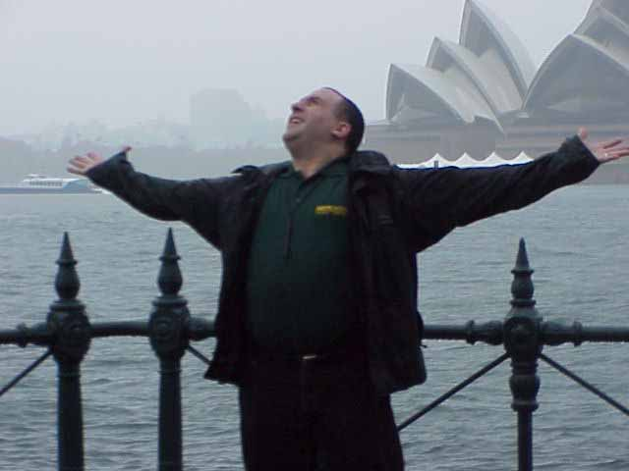
Mine is not the most riveting of stories going into San Diego. Kai and Mikey P are on major hot streaks, CMU has been drafting as well as any team I can remember, and there's a Masters to keep track of, but when you're checking out the Sideboard's coverage, if you're passing the time and you're curious, you can hit control + f, type Wise and see how I'm doing. I'll do a post San Diego report next week, but drama always seems like it's a lot more fun when watching it unfold. Really, it isn't drama if you know how it ends.
Wish me luck. Hopefully, I won't need it, but regardless of my success in the wins column, my main goal is to rediscover my competitive fire. If I do, all of the two point Pro Tours in the world won't matter, because I'll be playing a game I love, and I'll be doing it right. What more can you ask for?
Have a good week.

